The Final Hop — Challenge write-up
Description:
On the night of May 21 our SOC received a high-severity alert indicating unusual lateral movement in the Active Directory environment. Internal logs showed the Domain Controller (DC) was accessed by a suspicious account. A few hours later a critical application server became inaccessible. Booting from a recovery image revealed the local Administrator password had been changed without authorization.
You are asked to investigate, reconstruct the attacker’s actions, and recover the changed password.
Files provided:
A single archive containing two items: Case.ad1 (disk image) and capture.pcap[ng] (network capture).

Files link: DRIVE
Step 1 — Find the certificate (.pfx) in the disk image
I mounted/inspected Case.ad1 with FTK Imager and found a file server.pfx inside the Downloads folder. This .pfx (PKCS#12) file contains the server certificate and the private key — it is password protected and is the key to decrypting the RDP traffic if the TLS used RSA key exchange.
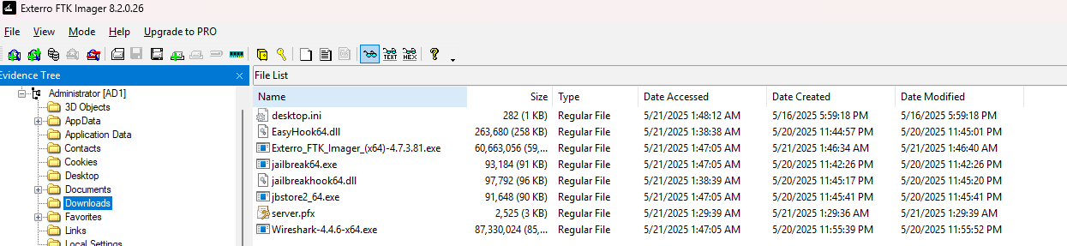

Step 2 — Convert the PFX for John the Ripper and crack the password
Convert the .pfx into a hash John can crack:
python3 pfx2john.py server.pfx > server.hash

Crack the password with John (using a wordlist):
john --wordlist=/usr/share/wordlists/rockyou.txt server.hash

John reported the cracked password: whatever.

Step 3 — Extract the private key (PEM)
Use OpenSSL to extract the private key from the .pfx. Because we have the password, we can export an unencrypted PEM:
openssl pkcs12 -in server.pfx -nocerts -nodes -out privatekey.pem -password pass:whatever

You should see MAC verified OK and a file privatekey.pem that begins with:
-----BEGIN PRIVATE KEY-----
...
-----END PRIVATE KEY-----

OPTIONAL:
openssl pkcs12 -in server.pfx -nokeys -clcerts -out server_cert.pem -password pass:whatever

Verify the key and cert match:
openssl rsa -in privatekey.pem -pubout -out pub_from_key.pem
openssl x509 -in server_cert.pem -pubkey -noout > pub_from_cert.pem
diff pub_from_key.pem pub_from_cert.pem && echo "MATCH" || echo "NO MATCH"

Step 4 — Identify the RDP/TLS stream in the pcap
Open the capture in Wireshark and find TLS traffic related to RDP. The server IP and port in this case were:
192.168.75.172 : 3389

(You can confirm this by filtering for tcp.port == 3389 or tls.handshake and inspecting the Server Hello packets.)

Step 5 — Load the private key into Wireshark and decrypt
In Wireshark go to:
Edit → Preferences → Protocols → TLS

Add an RSA key entry (RSA Keys List). Example entry:
- IP address: 192.168.75.172
- Port: 3389
- Protocol: rdp ← prefer rdp. If that fails try tcp.
- Key file: full path to privatekey.pem
Reopen the capture (or let Wireshark reparse).

Step 6 — Follow the decrypted stream and recover the flag
Right-click a TLS packet for the RDP session and choose:
Follow → TLS Stream (or Follow → TCP Stream)

AND WE GOT THE FLAG:
Asu{D0_Y0U_TRU5T_RDP_CERT?}
What I’ve tried:
I opened Cache000.bin but found nothing useful there
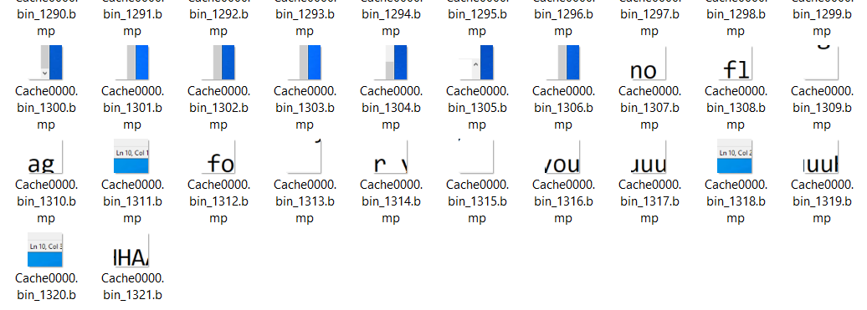
I got: “ no flag for youuuuuu ha”

Thanks for reading😊

